What is a Stub?

Stubs are used during Top-down integration testing, in order to simulate the behavior of the lower-level modules that are not yet integrated. Stubs are the modules that act as temporary replacement for a called module and give the same output as that of the actual product.

Stubs are also used when the software needs to interact with an external system.

Stub - Flow Diagram

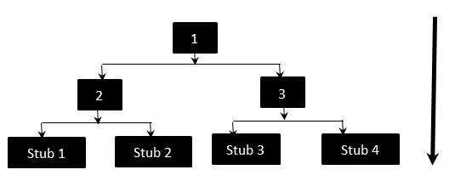

The above diagram clearly states that Modules 1, 2 and 3 are available for integration, whereas, below modules are still under development that cannot be integrated at this point of time. Hence, Stubs are used to test the modules.